Netflix FavList Application

# Entity Relationship Diagram(ERD) of the database design

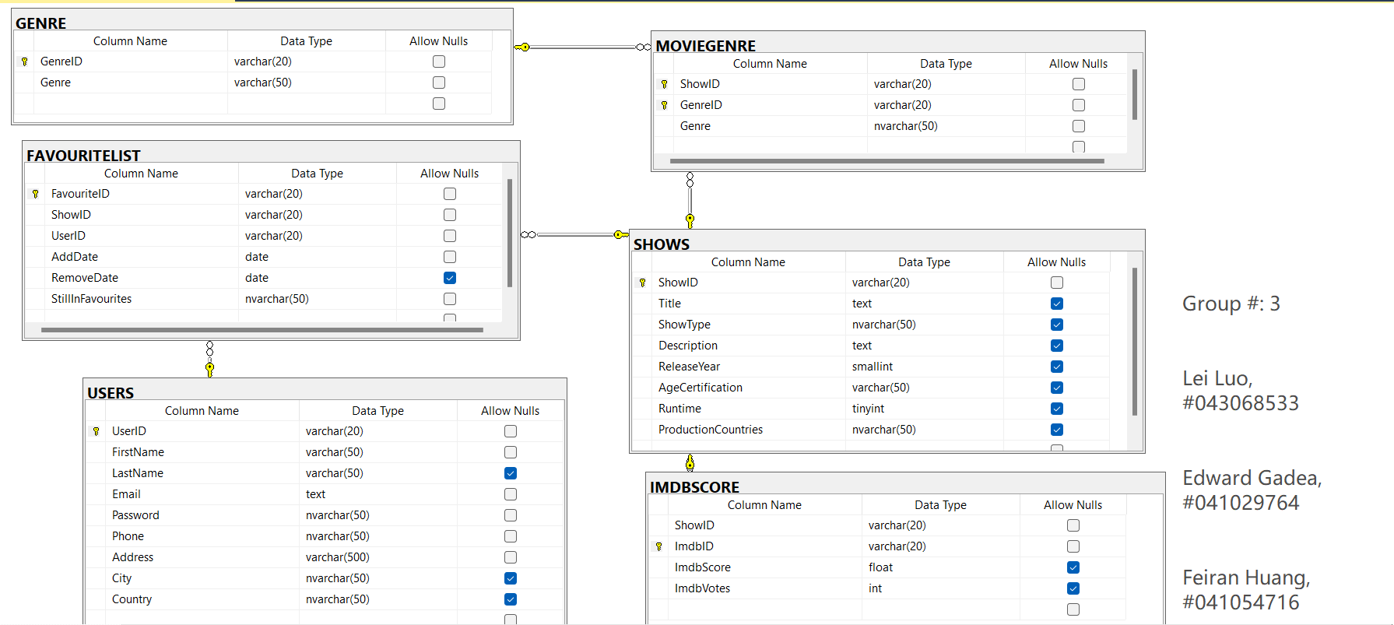

**Introduction**:

The MovieData database is designed to capture comprehensive information about Netflix shows and facilitate the tracking of user favorites. It consists of six tables.

The **SHOWS** table serves as the main table, containing important details such as ID, Title, ShowType, and more.

The **IMDBSCORE** table is linked to the SHOWS table through the show's ID and stores IMDb scores and user votes for each show. This allows users to access public ratings and reviews for Netflix content.

The **GENRE** table holds genre names and IDs, providing a list of available genres that shows can be categorized under.

The **MOVIEGENRE** table establishes the relationship between shows and genres by linking the show IDs from the SHOWS table with the corresponding genre IDs from the GENRE table. This enables efficient querying and filtering of shows based on their genres.

The **USERS** table stores simulated user data, including attributes such as FirstName, LastName, Email, Password, Phone, Address, City, and Country.

The **FAVOURITELIST** table enables users to track their favorite movies by associating each entry with a unique FavouriteID. This key is generated based on the combination of ShowID, UserID, and AddDate. The table includes additional attributes such as RemoveDate and StillInFavourites, allowing users to manage their favorite movie selections effectively.

# Installation and Backup Instructions for “Netflix FavList Application” Database

## 1 Installation Instructions:

1. Download the MovieData .bak file from BrightSpace Database course Group Assignment-Group 3 submission .
2. Install SQL Server Management Studio (SSMS) on your computer if you haven't already. You can download SSMS from the official Microsoft website: <https://www.microsoft.com/en-ca/sql-server/sql-server-downloads>

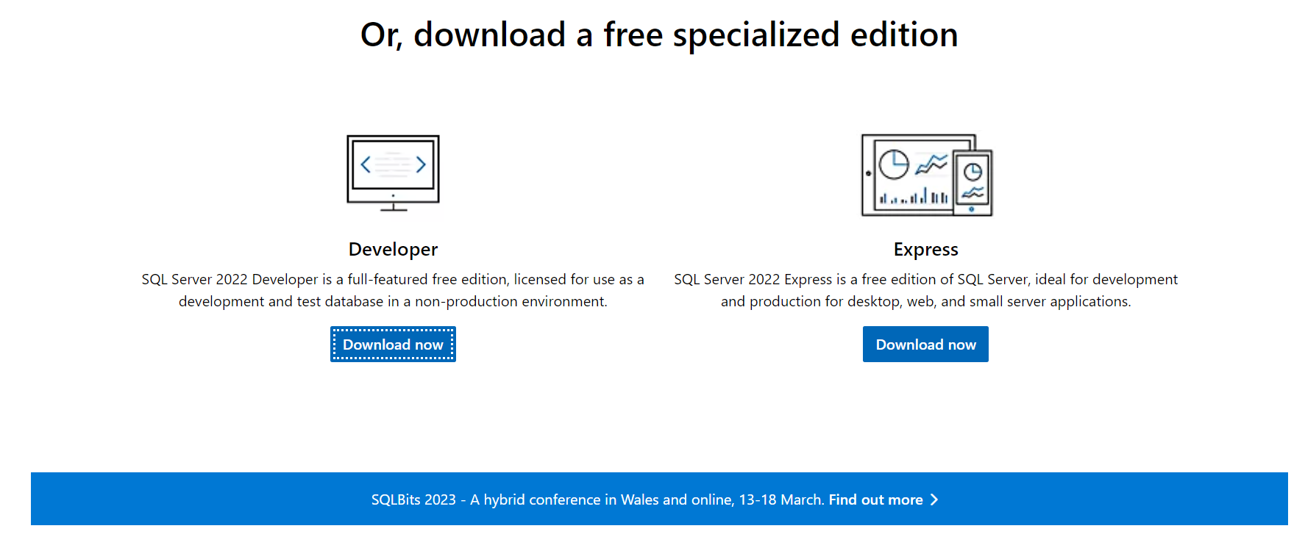

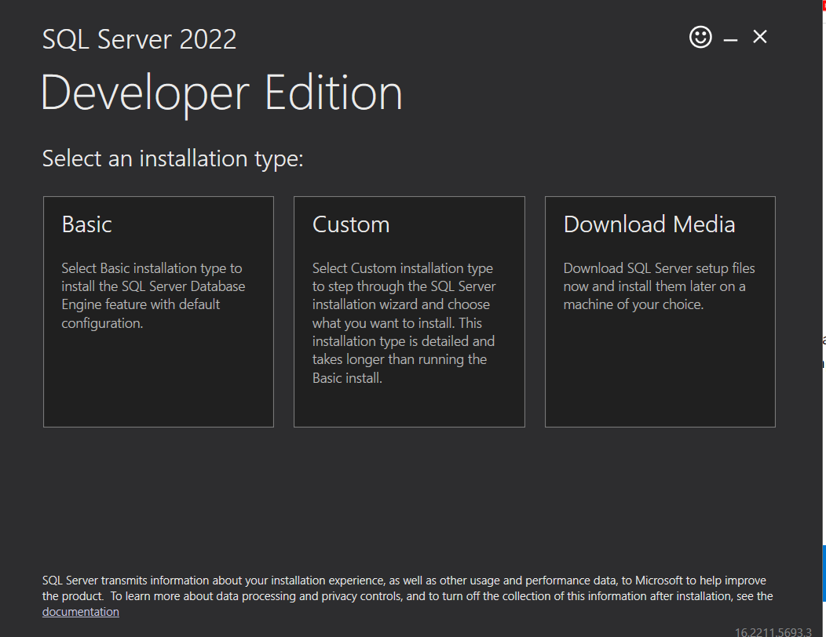

choose the “developer Edition”

1. On the confirmation screen, select “Install SSMS” to install the SQL Server Management Studio.
   1. You need to download Version 19 or later and then run the setup file.
2. When complete, open the SQL Server Management Studio in Windows.
   1. The first time you open the tool, save the launch screen – it shows your instance name.

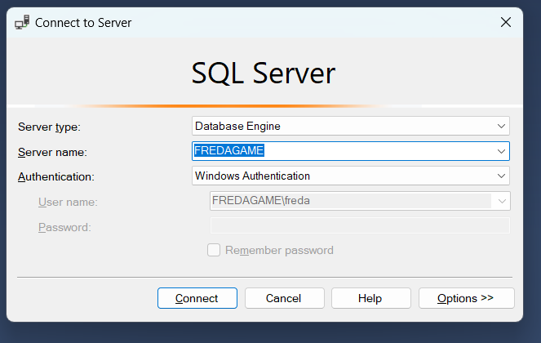

## 2 Install the MovieData.bak in your SMSS

1. Restore the backup to a new database called “MovieData” by following these steps:
   1. Select Databases > Restore Database …
2. Right-click on the "Databases" folder in the Object Explorer and select "Restore Database..."
3. In the "Restore Database" window, select the "Device" option and click on the "..." button.
4. In the "Select backup devices" window, click on the "Add" button and navigate to the location where you downloaded the MovieData .bak file.

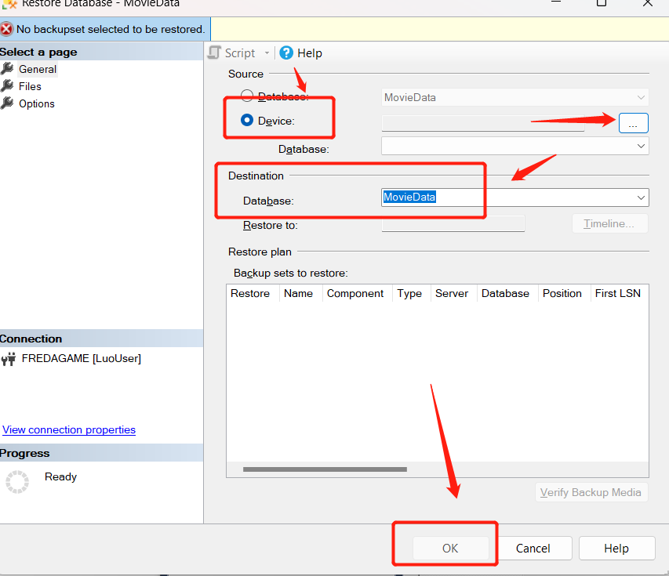

1. Select the .bak file and click "OK" to return to the "Restore Database" window.

Once the process is complete, you will have the movie data database available in your SQL Server instance.

## 3 Instructions for Connecting to Access with Remote Applications

We want to allow remote applications (not just local SSMS) to connect using a username/password without relying on Windows authentication.

* 1. Select your server and open the properties window.

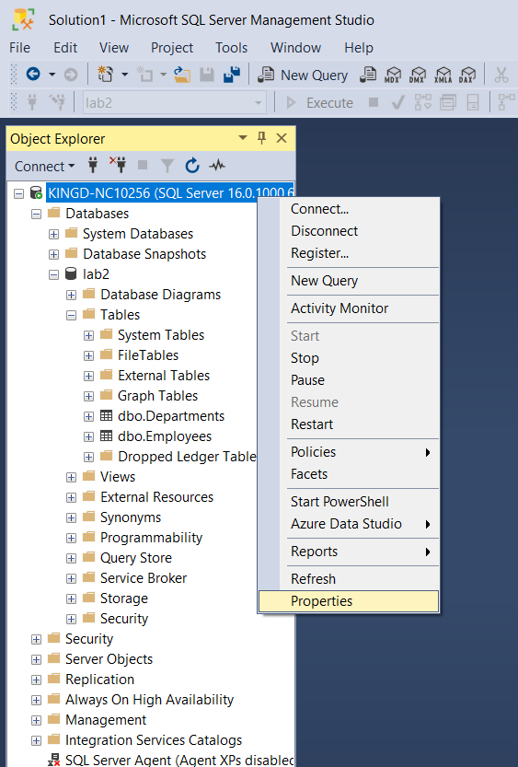

* 1. In the properties dialog, select the Security page and then the option for “SQL Server and Windows Authentication Mode”.

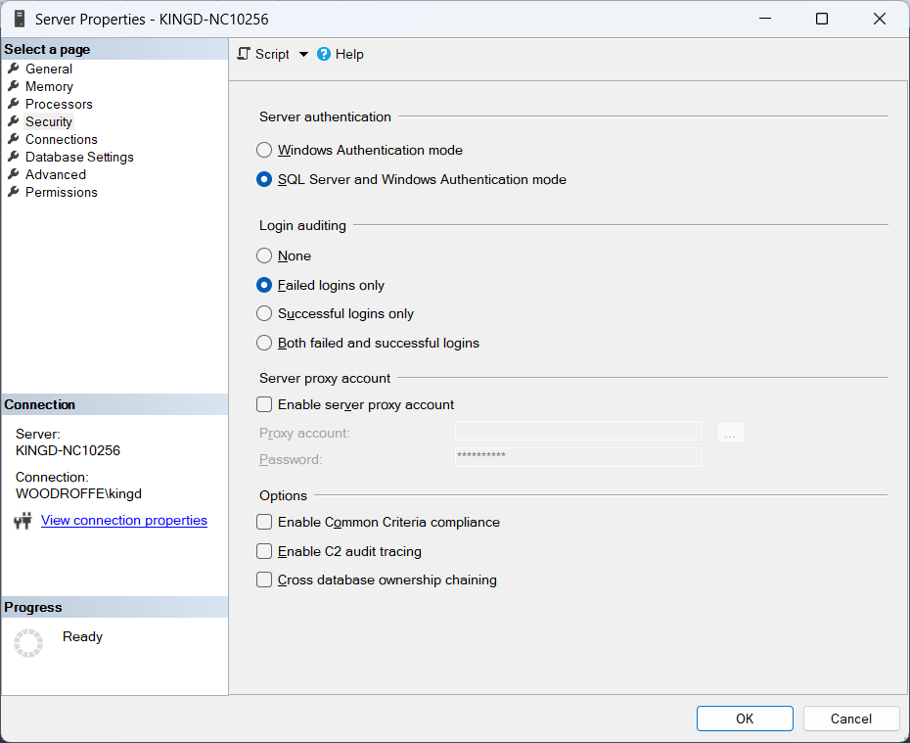

* 1. On the Connections page, select the “Allow Remote Connections to this server” option.

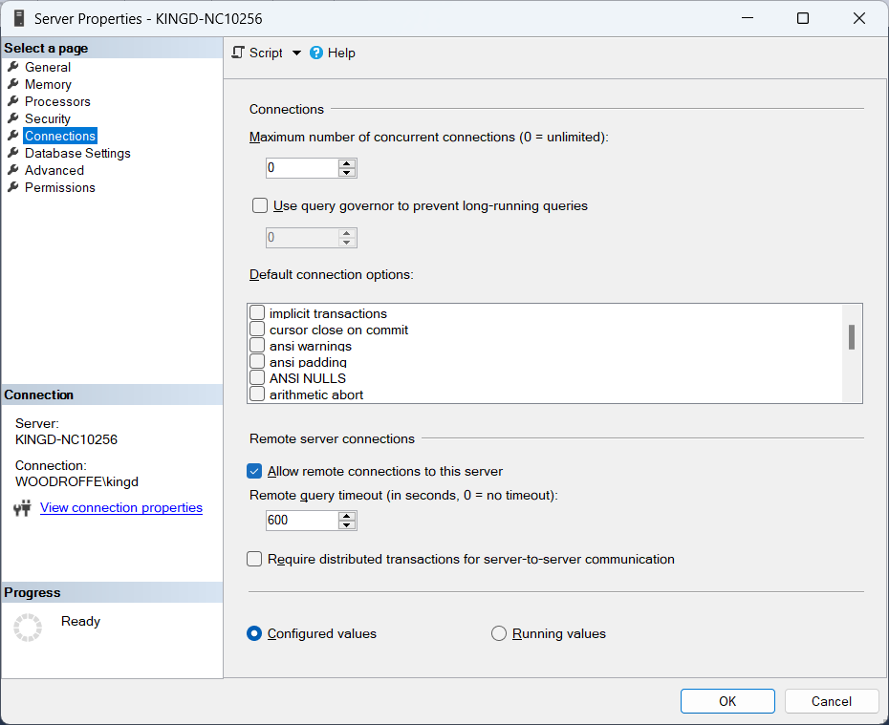

After you have made these changes, you will need to restart the server.

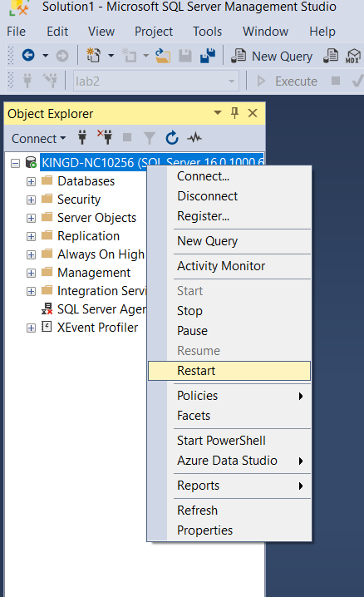

we need to create a new user account for our applications to use when they connect. Use yourlastnameUser (e.g., kingUser) with a simple password (e.g., k,ingPassword123) and perform the following steps:

* + 1. Open the dialog to create a new login

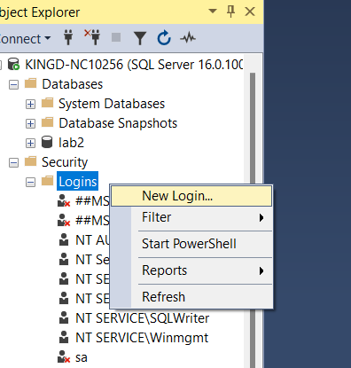

* + 1. In the dialog for New login, select the General page and fill in the following fields. This step needs to be done carefully – make sure you set the default database and unselect the password expiry fields…. Otherwise you will not be able to connect easily from applications.

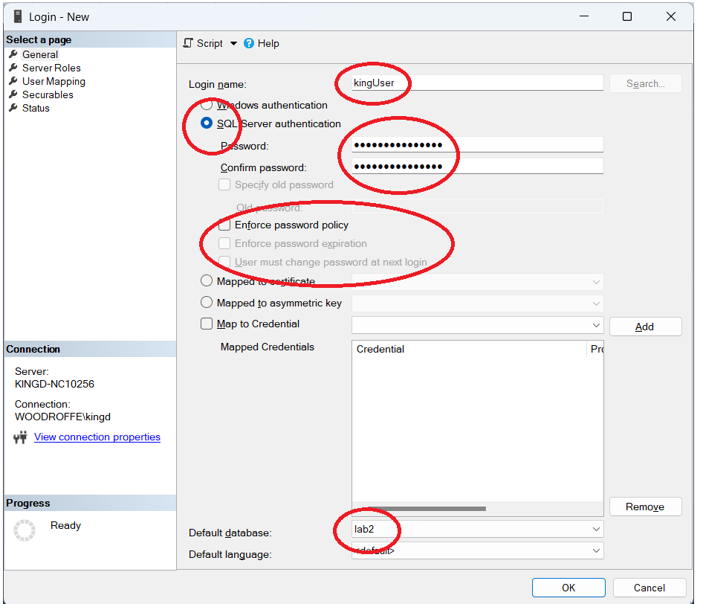

* 1. If successful, you will see your new login in the list…

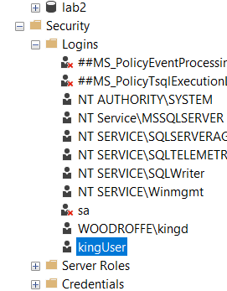

* 1. Now, while still connected as the Windows login user, (e.g., kingIser) run the following sql commands to change the ownership of the database lab2. (you will need to change the login name to yourlastnameUser).

USE MovieData;

EXEC sp_changedbowner 'kingUser', 'true';

## 4 Link to our new tables from the Access application

1. Open the Group03_Assignment01.accdb Microsoft Access file provided.
2. Close the welcome menu pop-up; we will need to ensure our database is tethered properly to the application.

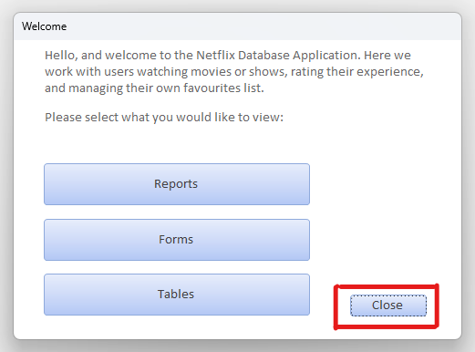

1. To the left, you will see all the application objects. In the “Tables” section, select all of the Tables, right click, and delete them. Don’t worry, we will be replacing them with tables from our newly restored MovieData database.

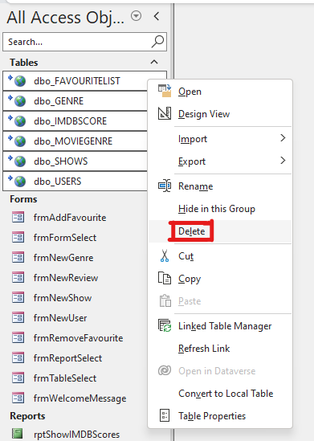

1. Then, in the top tabs, go to the "External Data" tab.
2. Click "New Data Source" in the "Import & Link" group, then “From DataBase” then “From SQL Server”
3. Choose the "Link to the data source by creating a linked table" option.

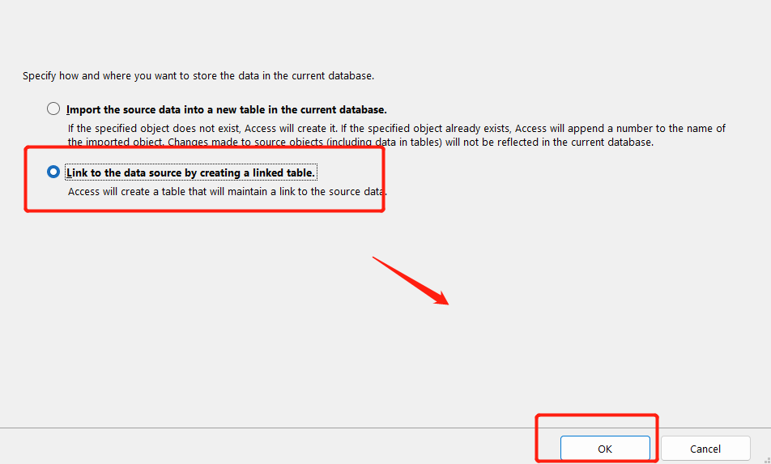

1. Create a new data source and enter the SQL Server connection details.
   1. Select "Machine Data Source" and choose your existing SQL Server connection.
   2. If you haven't created the connection yet, click "New" and follow the instructions to create a new one. Once created, return and select it.

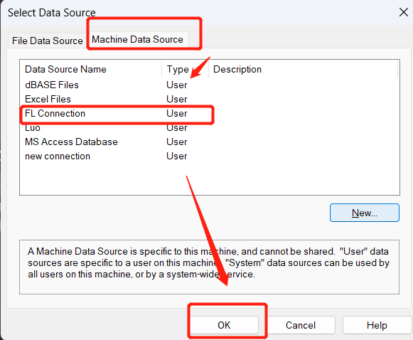

6. Test the connection to ensure it works.

7. Select the desired tables or views to link from the SQL Server database.

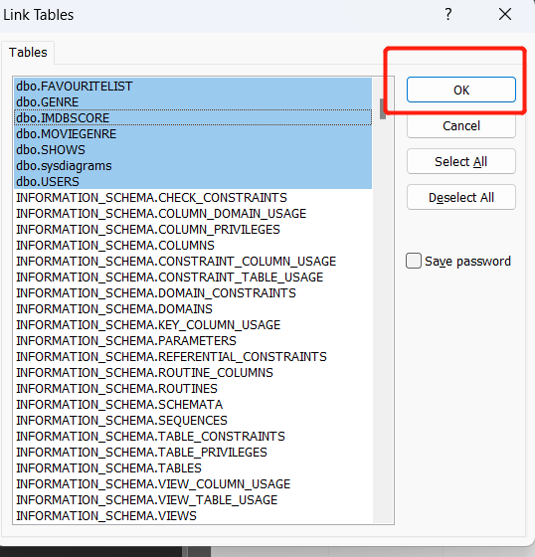

8. Access will create linked tables in your Access application.

9. Open SSMS and connect to the SQL Server database using the same connection details.

# Backup Instructions

1. Launch SQL Server Management Studio and connect to your SQL Server instance.
2. Right-click on the movie data database in the Object Explorer and select "Tasks" > "Back Up..."
   1. Make sure you select the “Copy Only” option.
3. In the "Back Up Database" window, verify that the correct database is selected for backup.

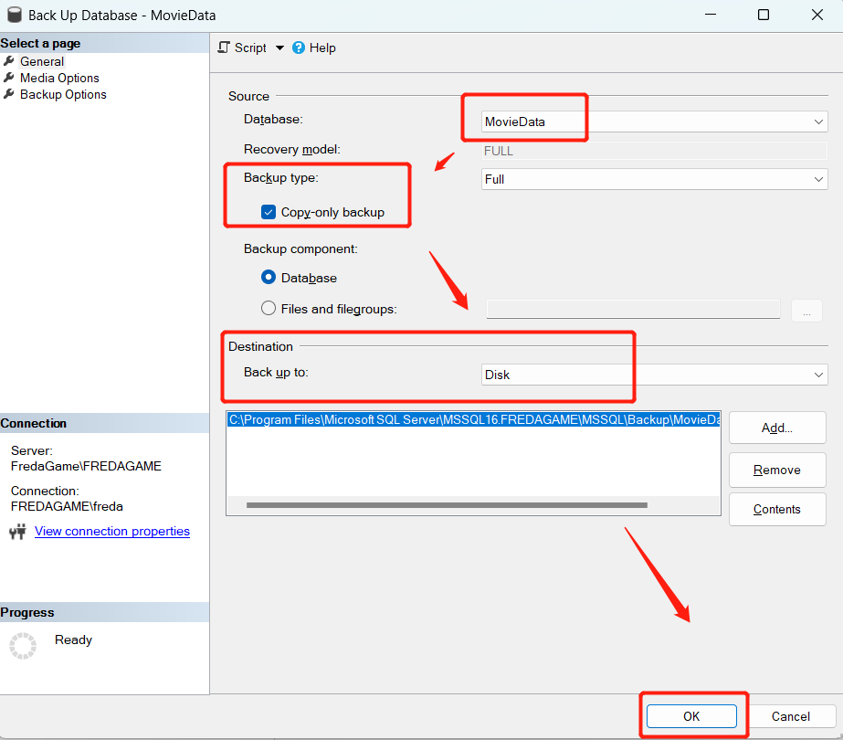

1. Choose the backup destination by selecting "Disk" and specify the location where you want to store the backup file (.bak).
2. Click "OK" to start the backup process. Once the backup is complete, you will have a .bak file containing the movie data backup.

**Note:** Make sure to update the connection details (e.g., server name, credentials) in Access if there are any changes to the SQL Server database connection.

# Application Overview for “Netflix FavList”

**Business Rule: Netflix FavList Application**

1. Only registered users with a valid account can add shows to their favorite list in the Netflix FavList Application. Users must have a valid account and be logged in to the application to access and update their favorite show selections.
2. Required User Information: A valid user account must have at least the following information: FirstName, LastName, Email, Password, Phone, and Address.
3. Show Information: Each show in the SHOWS table has Title, ShowType, Description, ReleaseYear, AgeCertification, Runtime, and ProductionCountries related information.
4. The GENRE table provides a list of available genres, allowing shows to be categorized under specific genres.
5. Login users can add as many shows as they want to their favorite list, remove shows, and add them back again.

## Back end description

The database MovieData consists of six tables:

1. SHOWS: This table contains a comprehensive listing of Netflix TV shows and movies sourced from Kaggle. It includes essential show information such as ID, Title, ShowType, etc. (source: Netflix TV Shows and Movies | Kaggle).

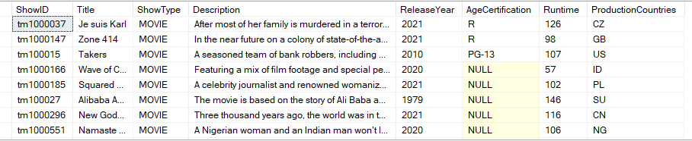

1. IMDBSCORE: This table stores the IMDb scores and user votes for each show. It serves as a reference for public ratings and is linked to the Shows table through the show's ID.

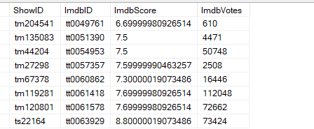

1. GENRE: This table holds genre names and IDs. It provides a list of available genres that shows can be categorized under.

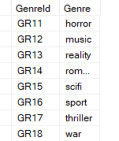

1. MOVIEGENRE: This table establishes the relationship between shows and genres. It links the show IDs from the Shows table with the corresponding genre IDs from the Genre table.

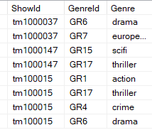

1. User: This table contains simulated user data. It includes attributes such as UserID, FirstName, LastName, Email, Password, Phone, Address, City, and Country. Each row represents a unique user in the system.

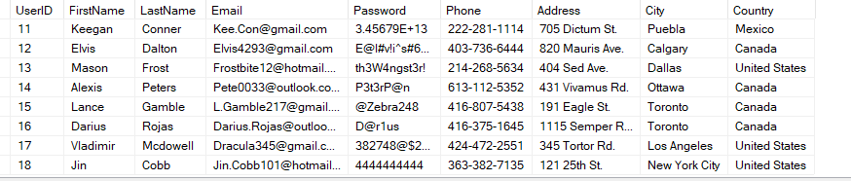

1. FavouriteList: This table allows users to track movies they have chosen as their favorites. It includes attributes such as FavouriteID, ShowID, UserID, AddDate, RemoveDate, and StillInFavourites. The ShowID column references the ShowID in the SHOWS table, and the UserID column references the primary key UserID in the USERS table. AddDate represents the date when a user added a show to their favorite list, RemoveDate indicates the date when a user removed a show from their favorite list, and StillInFavourites is a flag to check if the show is still in the user's favorite list. The primary key in this table is **FavouriteID**, which is generated based on the combination of ShowID, UserID, and AddDate.

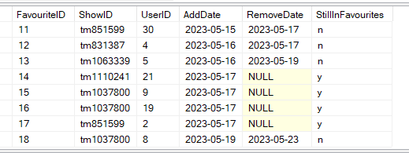

## Front end description

The Application consists of 6 reports, and 10 forms:

**Forms**

1. The Welcome form (frmWelcomeMessage), used as a central menu to connect all of the database objects through a series of navigation buttons (More information about form usage in the User Instructions Section). Can be reached upon opening the application.

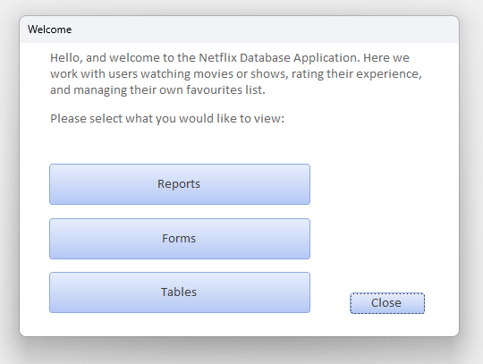

1. The Report Select form (frmReportSelect), containing a selection of 6 buttons, named according to the report each button will open. Can be reached at Welcome > Reports.

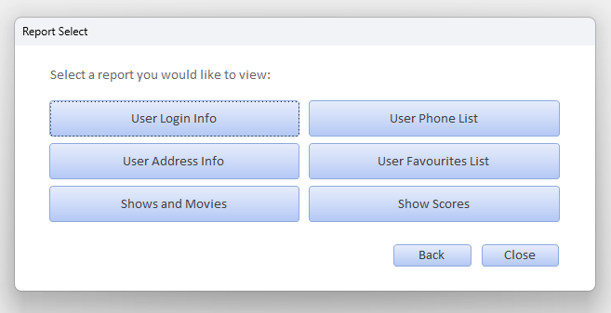

1. The Form Select form (frmFormSelect), containing a selection of 6 buttons, named according to the Form each button will open. Can be reached at Welcome > Forms.

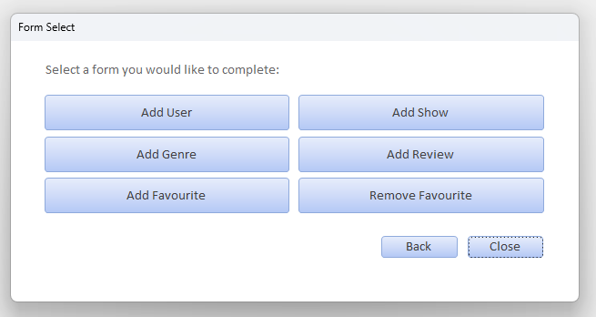

1. The Table Select form (frmTableSelect), containing a selection of 6 buttons, named according to the Table each button will open. Can be reached at Welcome > Tables.

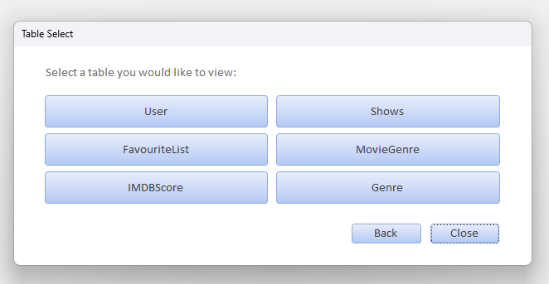

1. The New User form (frmNewUser), containing a series of text boxes labeled by specific information expected to be filled in. This form will append a new row into the dbo_USERS table upon clicking the Submit button. Can be reached at Welcome > Forms > Add User.

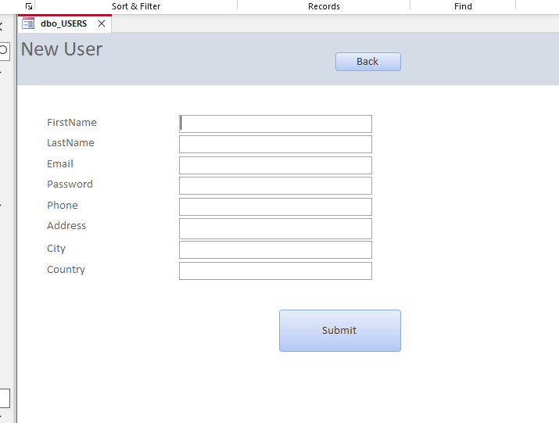

1. The New Show form (frmNewShow), containing a series of text boxes and combo boxes labeled by specific information expected to be filled in. This form will append a new row into the dbo_SHOWS table and the dbo_MOVIEGENRE table upon clicking the Submit button. Can be reached at Welcome > Forms > Add Show.

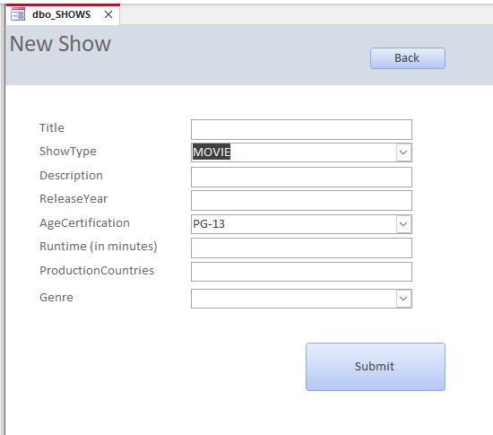

1. The New Genre form (frmNewGenre), containing a text box labeled “Genre”. This form will append a new row into the dbo_GENRE table upon clicking the Submit button. Can be reached at Welcome > Forms > Add Genre.

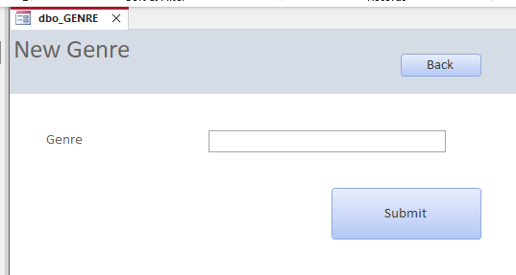

1. The New Review form (frmNewReview), containing a text box requesting a movie title, and a combo box requesting a numeric rating from 1 to 10. This form will append a new row into the dbo_IMDBSCORE table upon clicking the Submit button. Can be reached at Welcome > Forms > Add Review.

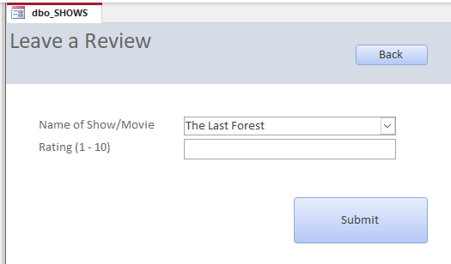

1. The Add Favourite form (frmAddFavourite), containing 2 text boxes requesting a first and last name, and a combo box requesting a movie title. This form will append a new row into the dbo_FAVOURITELIST table upon clicking the Submit button. Can be reached at Welcome > Forms > Add Favourite.

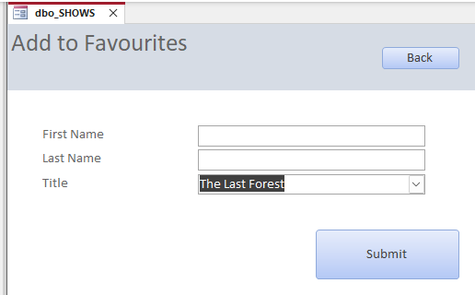

1. The Remove Favourite form (frmRemoveFavourite), very similar to the Add Favourite form, except upon clicking the Submit button after filling in the data, the information will simply be used to find the row in dbo_FAVOURITELIST and add a RemoveDate, also converting the StillInFavourites value to ‘n’. Can be reached at Welcome > Forms > Remove Favourite.

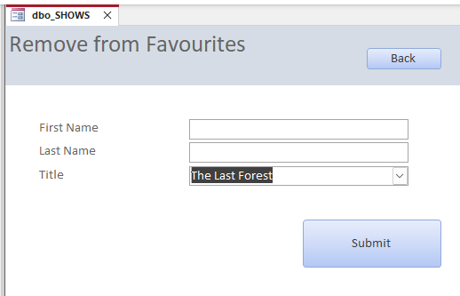

**Reports**

1. The Show Scores report (rptShowIMDBScores), which will present the info on movie reviews, including the Title, whether it's a Show or Movie, its average score on IMDB, and the number of IMDB reviews. This form (much like any of the other forms), contains a Back button which can be used to go back to the Report Select form. Can be reached at Welcome > Reports > Show Scores.

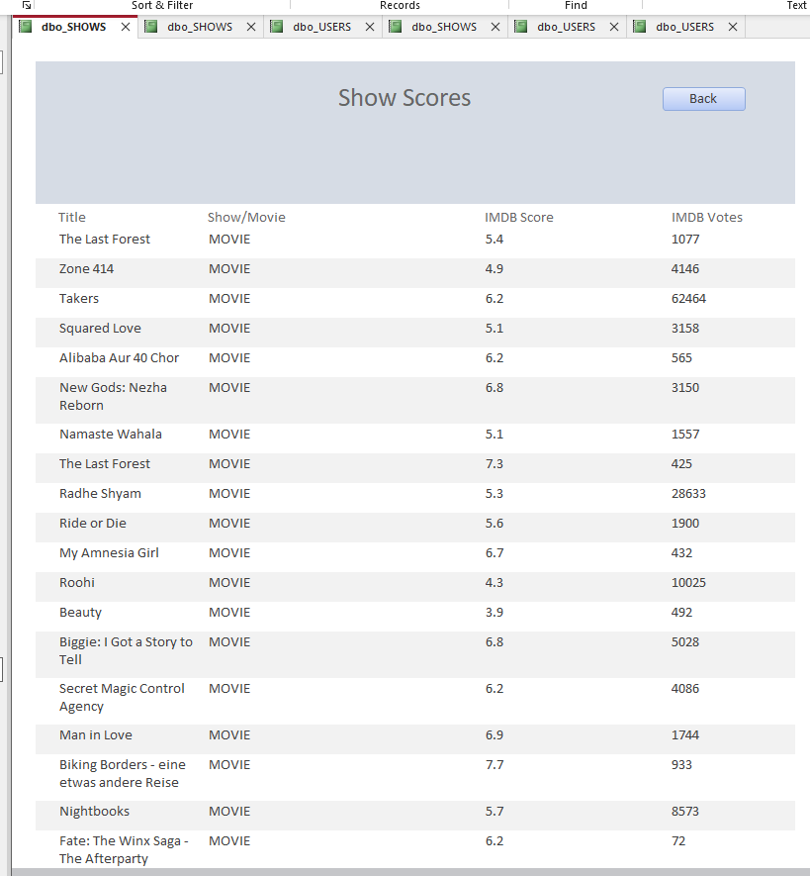

1. The Shows and Movies report (rptShowsAndMovies), which will present the info on shows and movies, including the Title, the Description, its production Year, the Age Rating, its Runtime, the Country of production, and the Genre. Can be reached at Welcome > Reports > Shows and Movies.

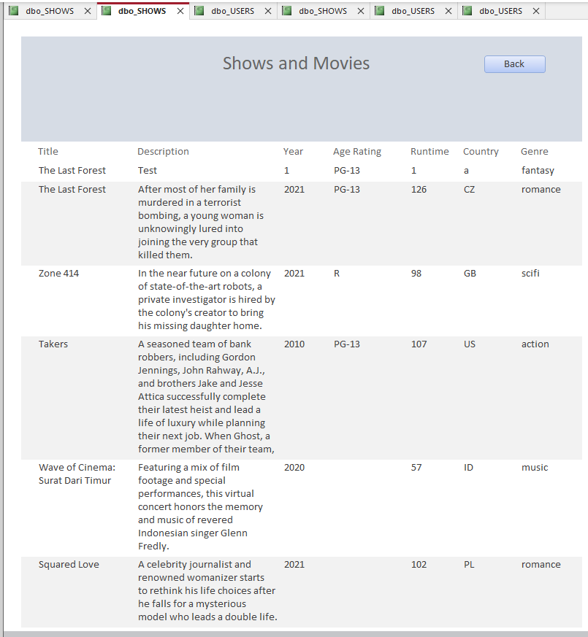

1. The User Address Info report (rptUserAddressList), which will present the info on the User’s Address, including the user’s FirstName, LastName, as well as their Address, City, and Country of residence. Can be reached at Welcome > Reports > User Address Info.

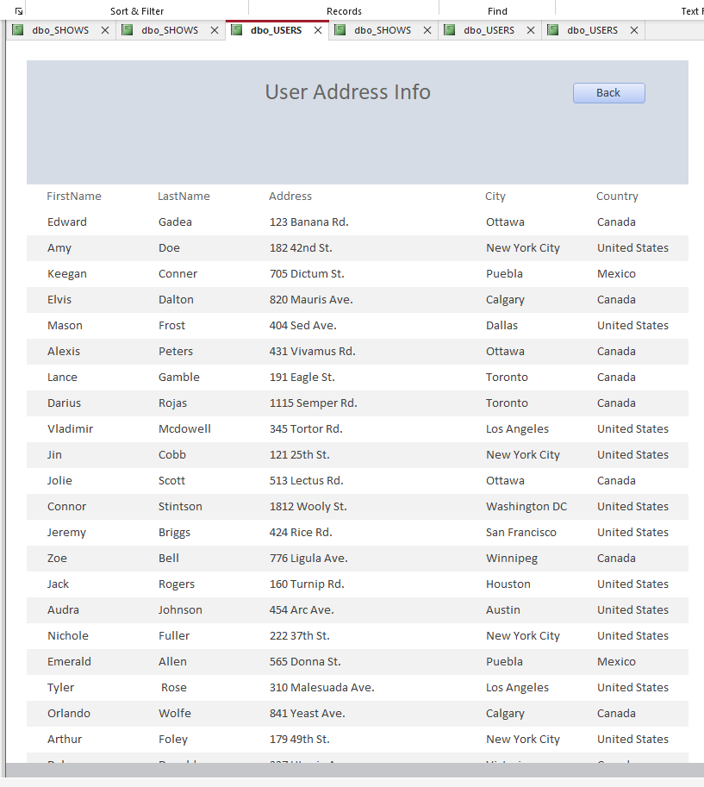

1. The User Favourite List report (rptUserFavourites), which will present the info on each user’s favourite movies and shows, including the Title, the user’s FirstName and LastName, the date it was Added on, the date it was Removed on (if applicable), and whether its StillInFavourites with a ‘y’ or a ‘n’ for yes and no. Can be reached at Welcome > Reports > User Favourites List.

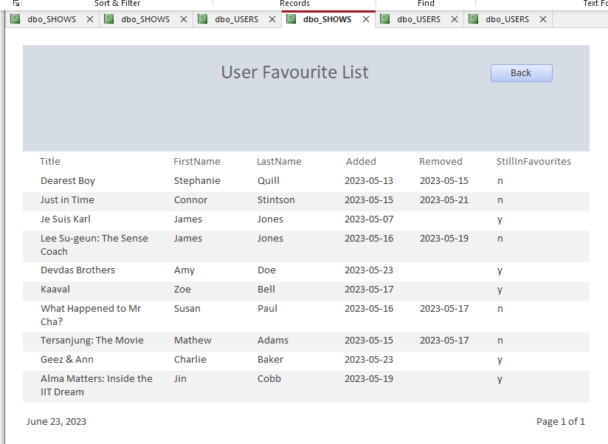

1. The User Login Info report (rptUserLoginInfo), which will present the info on the user’s Login Info, including the user’s FirstName, LastName, their Email, and their Password. Can be reached at Welcome > Reports > User Login Info.

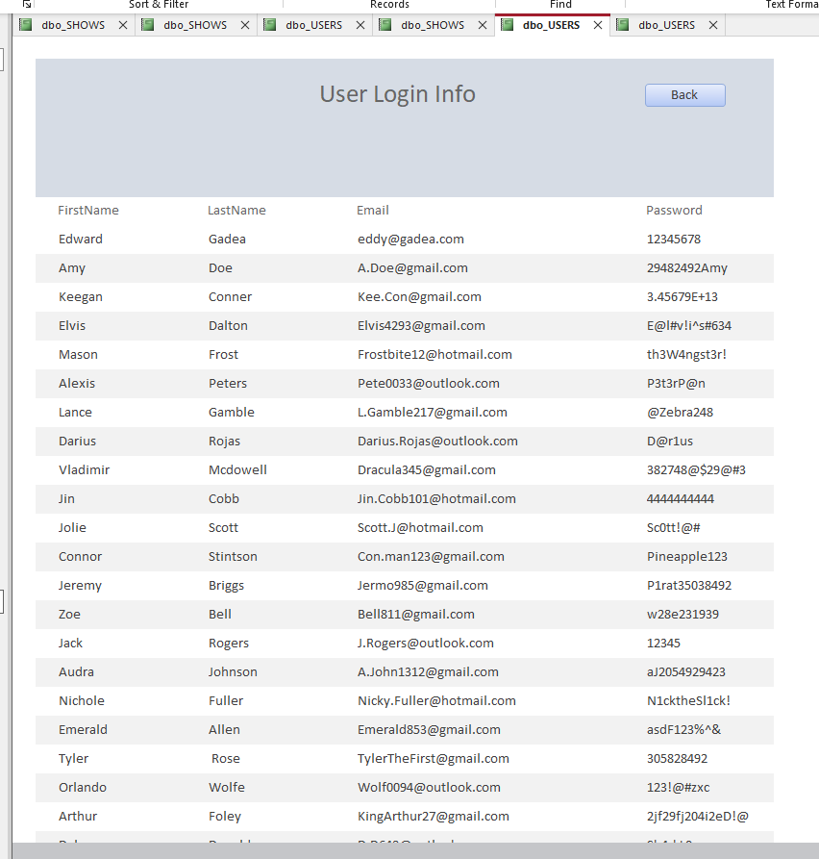

1. The User Phone List report (rptUserPhoneList), which will present the info on the user’s Phone number, including the user’s FirstName, LastName, and their Phone number. Can be reached at Welcome > Reports > User Phone List.

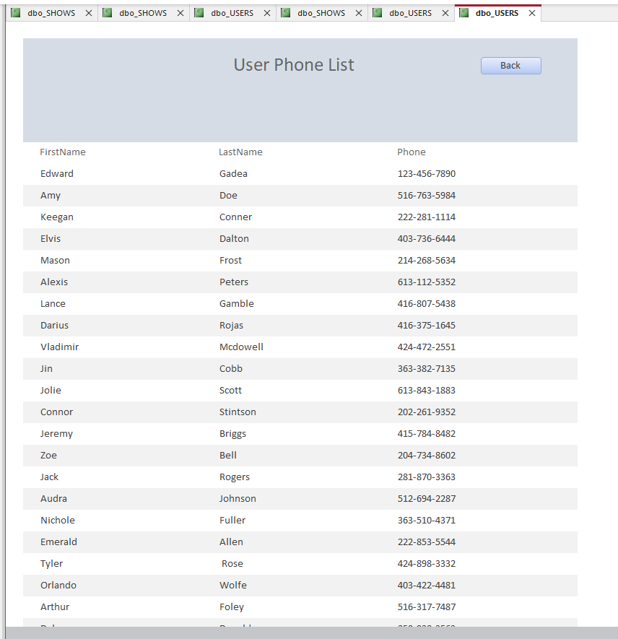

# 

# User instructions

The Netflix FavList Application provides users with a platform to discover and manage their favorite Netflix shows. It ensures that registered users can access and modify their favorite list while maintaining the necessary show and user information for a seamless and personalized user experience.

**How to navigate and use the Netflix FavList Application**

1. The first thing you will see when opening the application is a pop-up form containing a welcome message as well as 4 navigation buttons: Reports, Forms, Tables, and Close. Each of these buttons represent different paths you can take to utilize the application to its fullest.



* 1. The Reports button will take you to a new form, the Report Select. Much like the Welcome form, this form contains a variety of buttons which will take you to the specified reports, for example the “User Login Info” button will take you to the “rptUserLoginInfo” report in the application.
     1. ADVISORY: Sometimes the report takes a while to load when you first open the Access file! Don’t panic if this happens, instead give it a minute to load. After some time the report should open, and future report opens should be instant.
     2. There is also a Back button and a Close button. The Back button will take you back to the Welcome form, while the Close button will close this form.

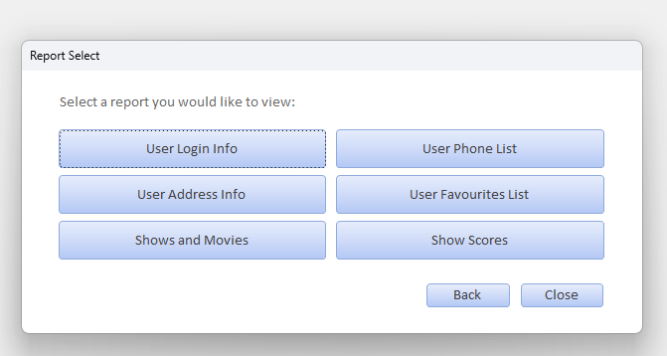

* + 1. Within each report, there will be a Back button, which can be used to return to the Report Select form.

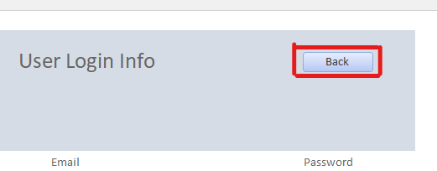

* 1. Back to the Welcome form, the Forms button will take you to the Form Select form, where you will be able to select a form you would like to complete. This uses a very similar format to the Report Select form, where each button will take you to a different form, except for the Back and Close Buttons.



* + 1. Within each form, there will be text fields where you will fill in data to append a new row to the database. Once you complete filling in the data required, you can select the Submit button to append that data into a new row in the respective table.

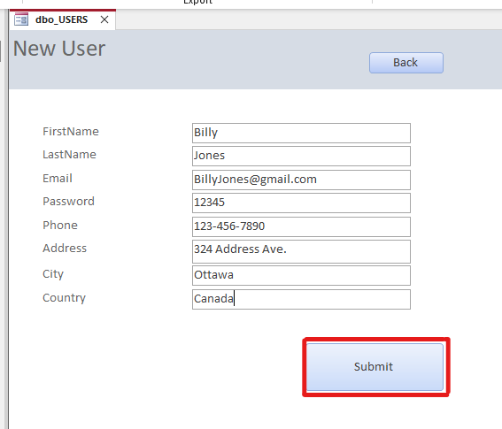

* + - 1. When you press the submit button, the application will confirm that you wish to append 1 row into the database. Select “Yes” after verifying your information is correct. Make sure your front end is properly linked to the back end before appending a new row (see Linking Tables from Access).

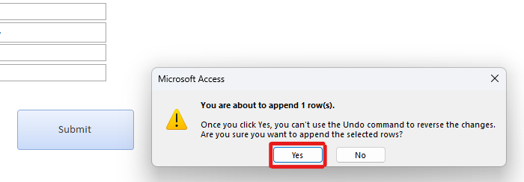

* + - 1. After which, the application will automatically take you back to the Welcome form.
  1. Back to the Welcome form, the Tables button will take you to the Table Select form, where you will be able to select a table you would like to view. Each button will take you to its respective table, in case you just want to view the raw data.

